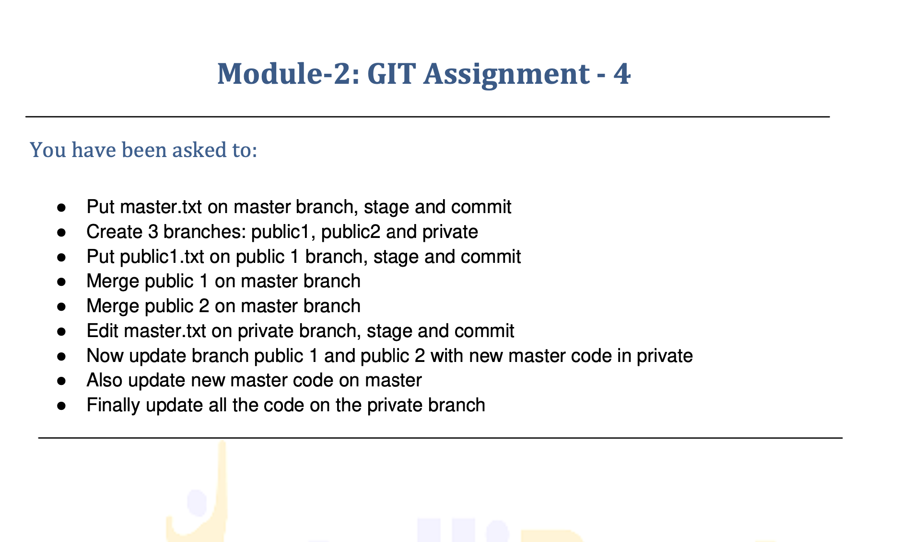

You have been asked to:

* ●  Put master.txt on master branch, stage and commit
* ●  Create 3 branches: public1, public2 and private
* ●  Put public1.txt on public 1 branch, stage and commit
* ●  Merge public 1 on master branch
* ●  Merge public 2 on master branch
* ●  Edit master.txt on private branch, stage and commit
* ●  Now update branch public 1 and public 2 with new master code in private
* ●  Also update new master code on master
* ●  Finally update all the code on the private branch

-------------------------------------------------------------------------------------------

* Put master.txt on master branch, stage and commit

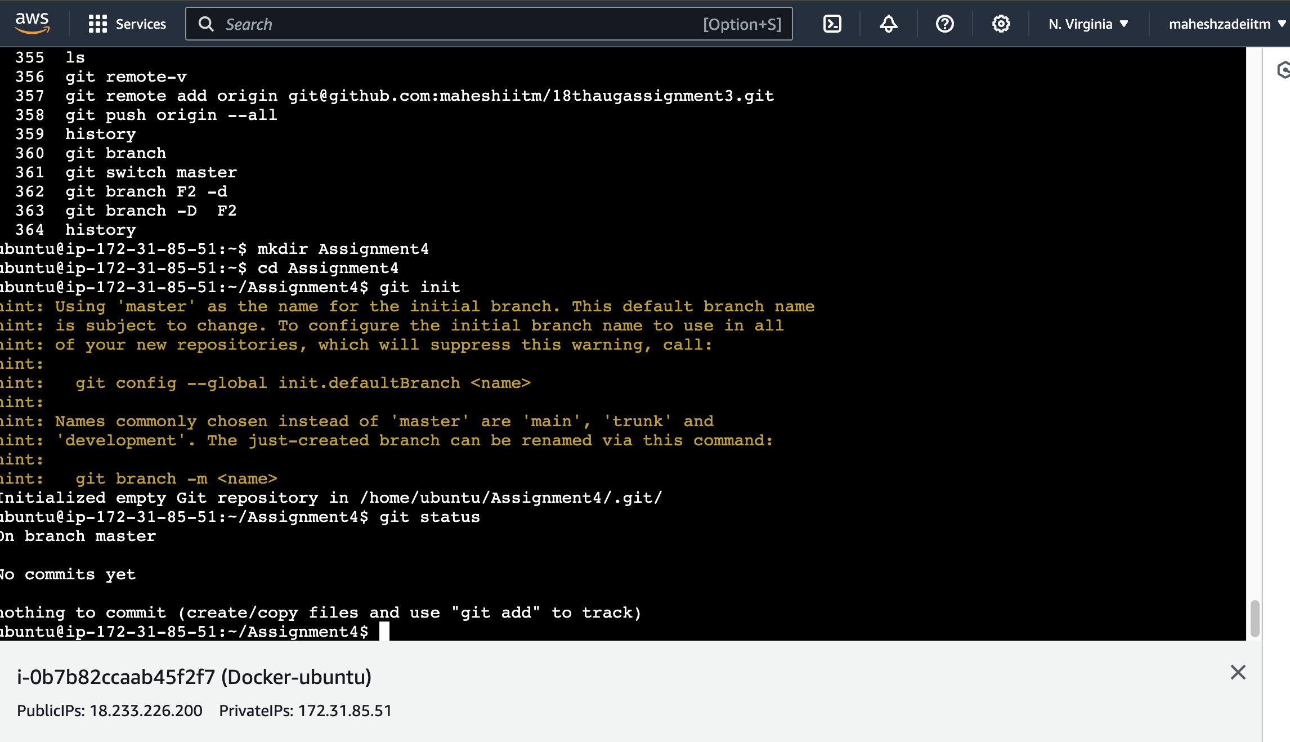

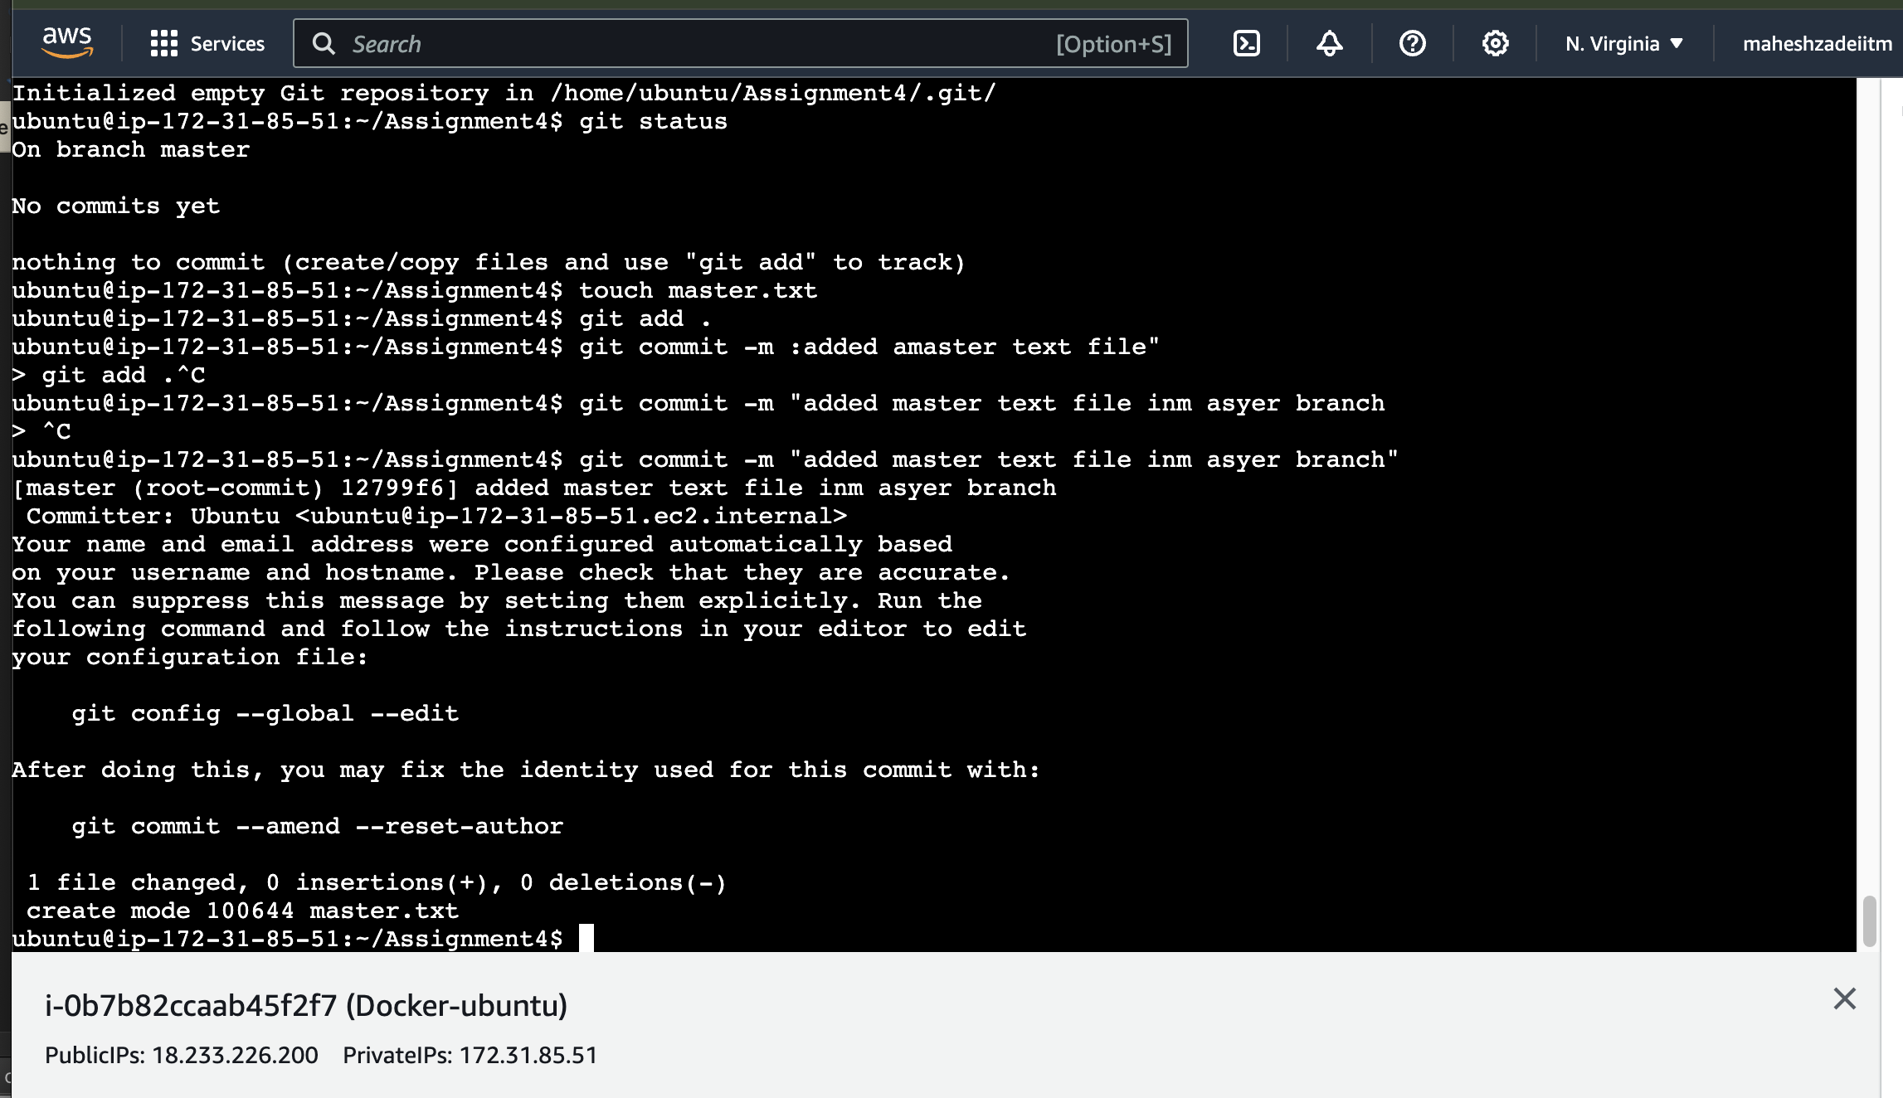

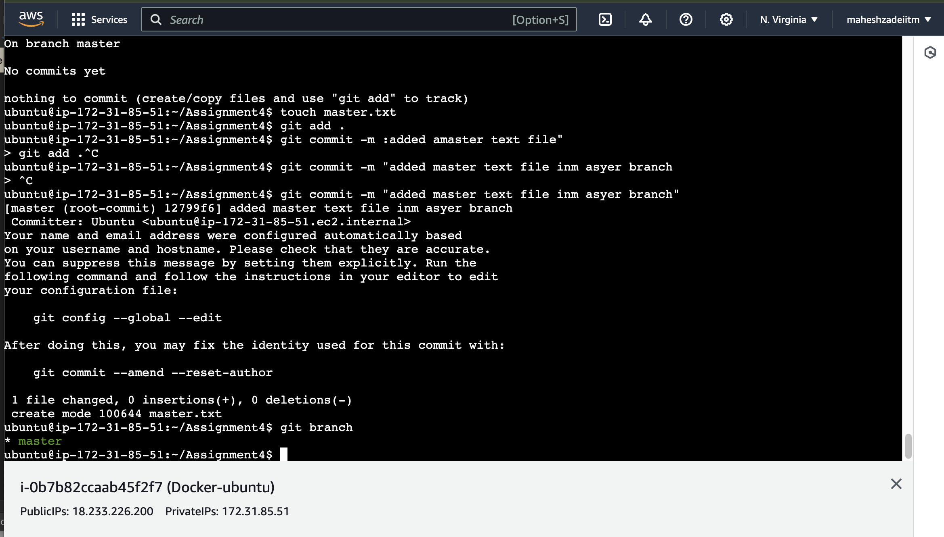

Create 3 branches: public1, public2 and private

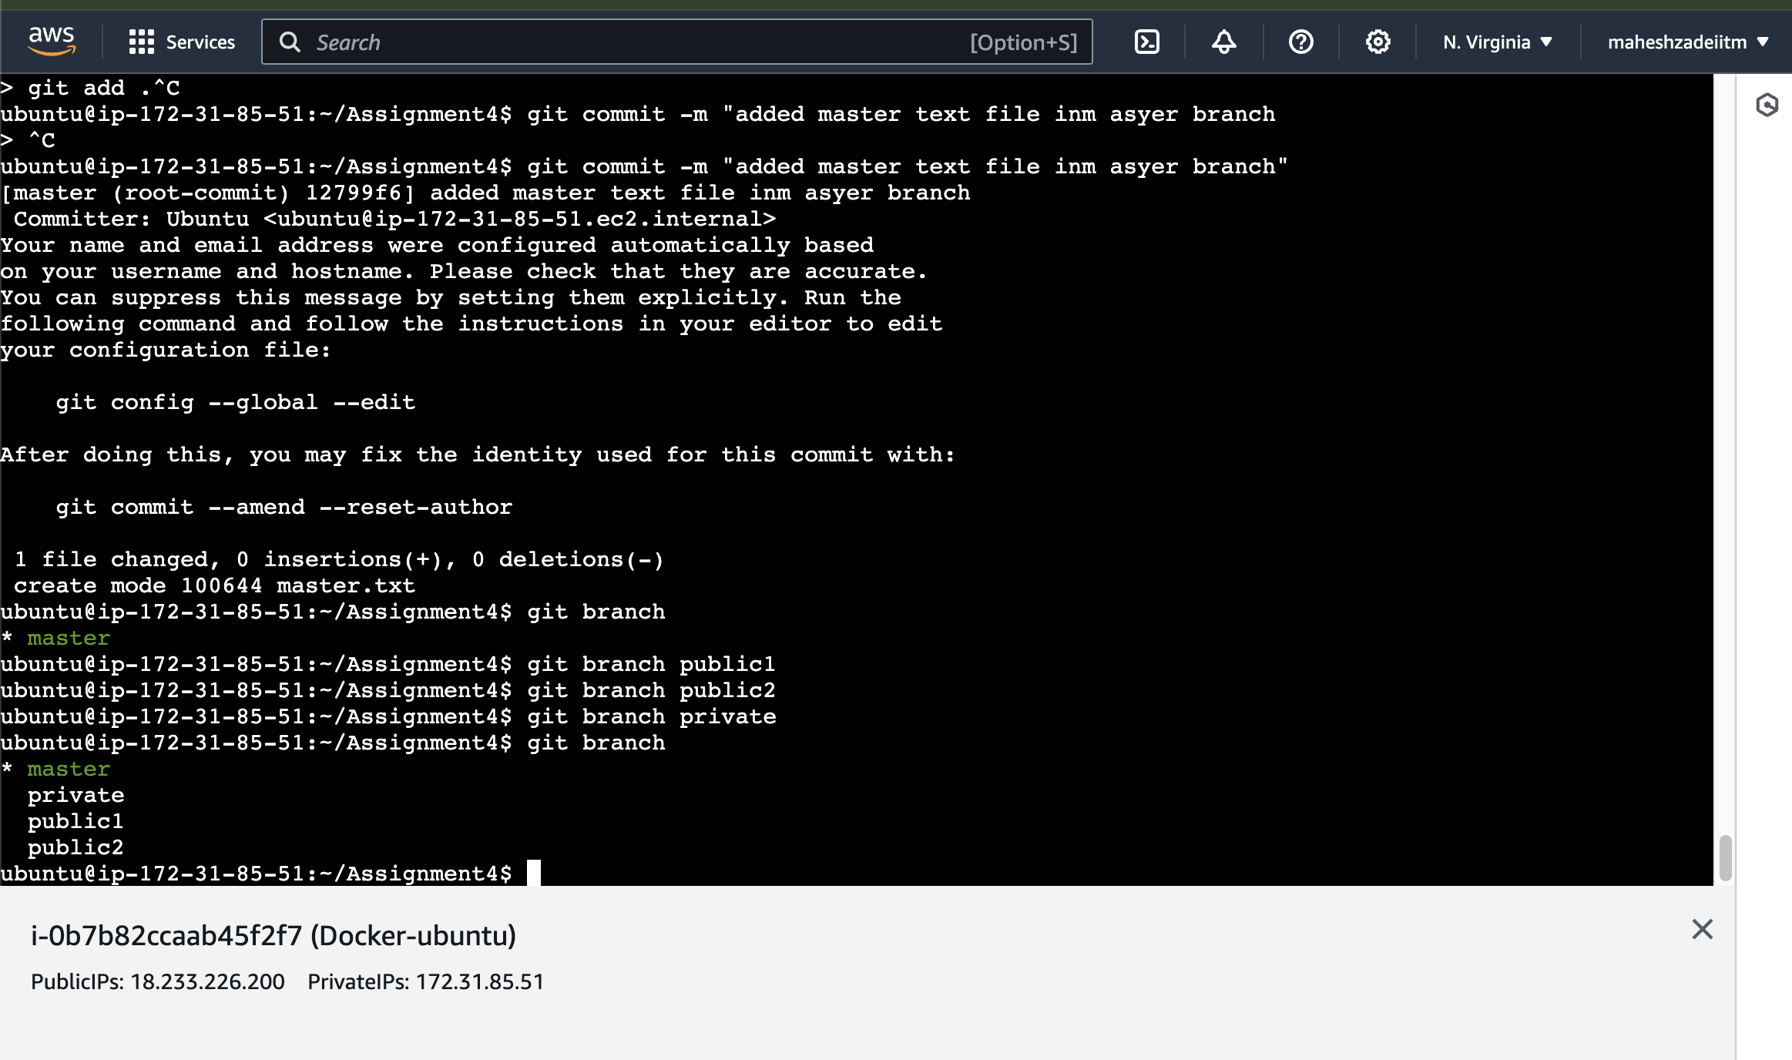

Put public1.txt on public 1 branch, stage and commit

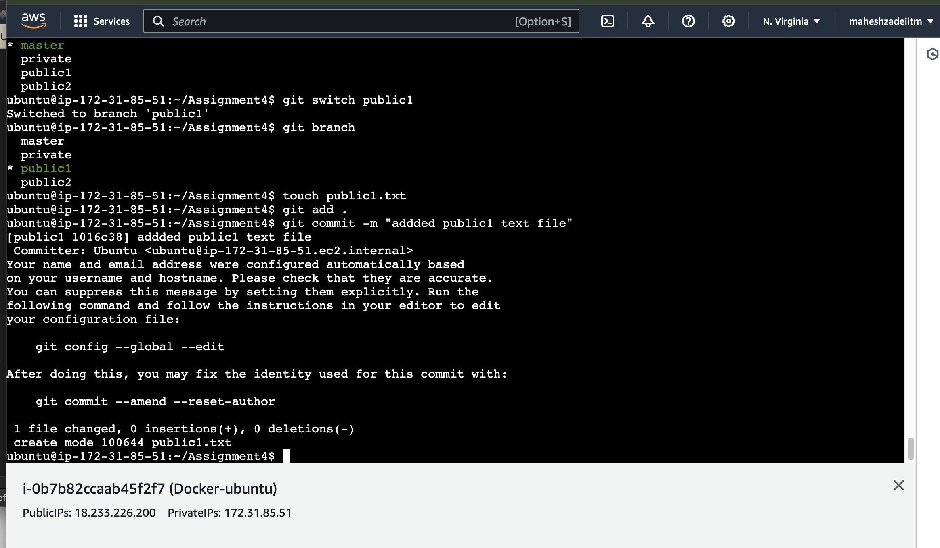

ubuntu@ip-172-31-85-51:~/Assignment4$ git status

On branch public1

nothing to commit, working tree clean

Now

Merge public 1 on master branch

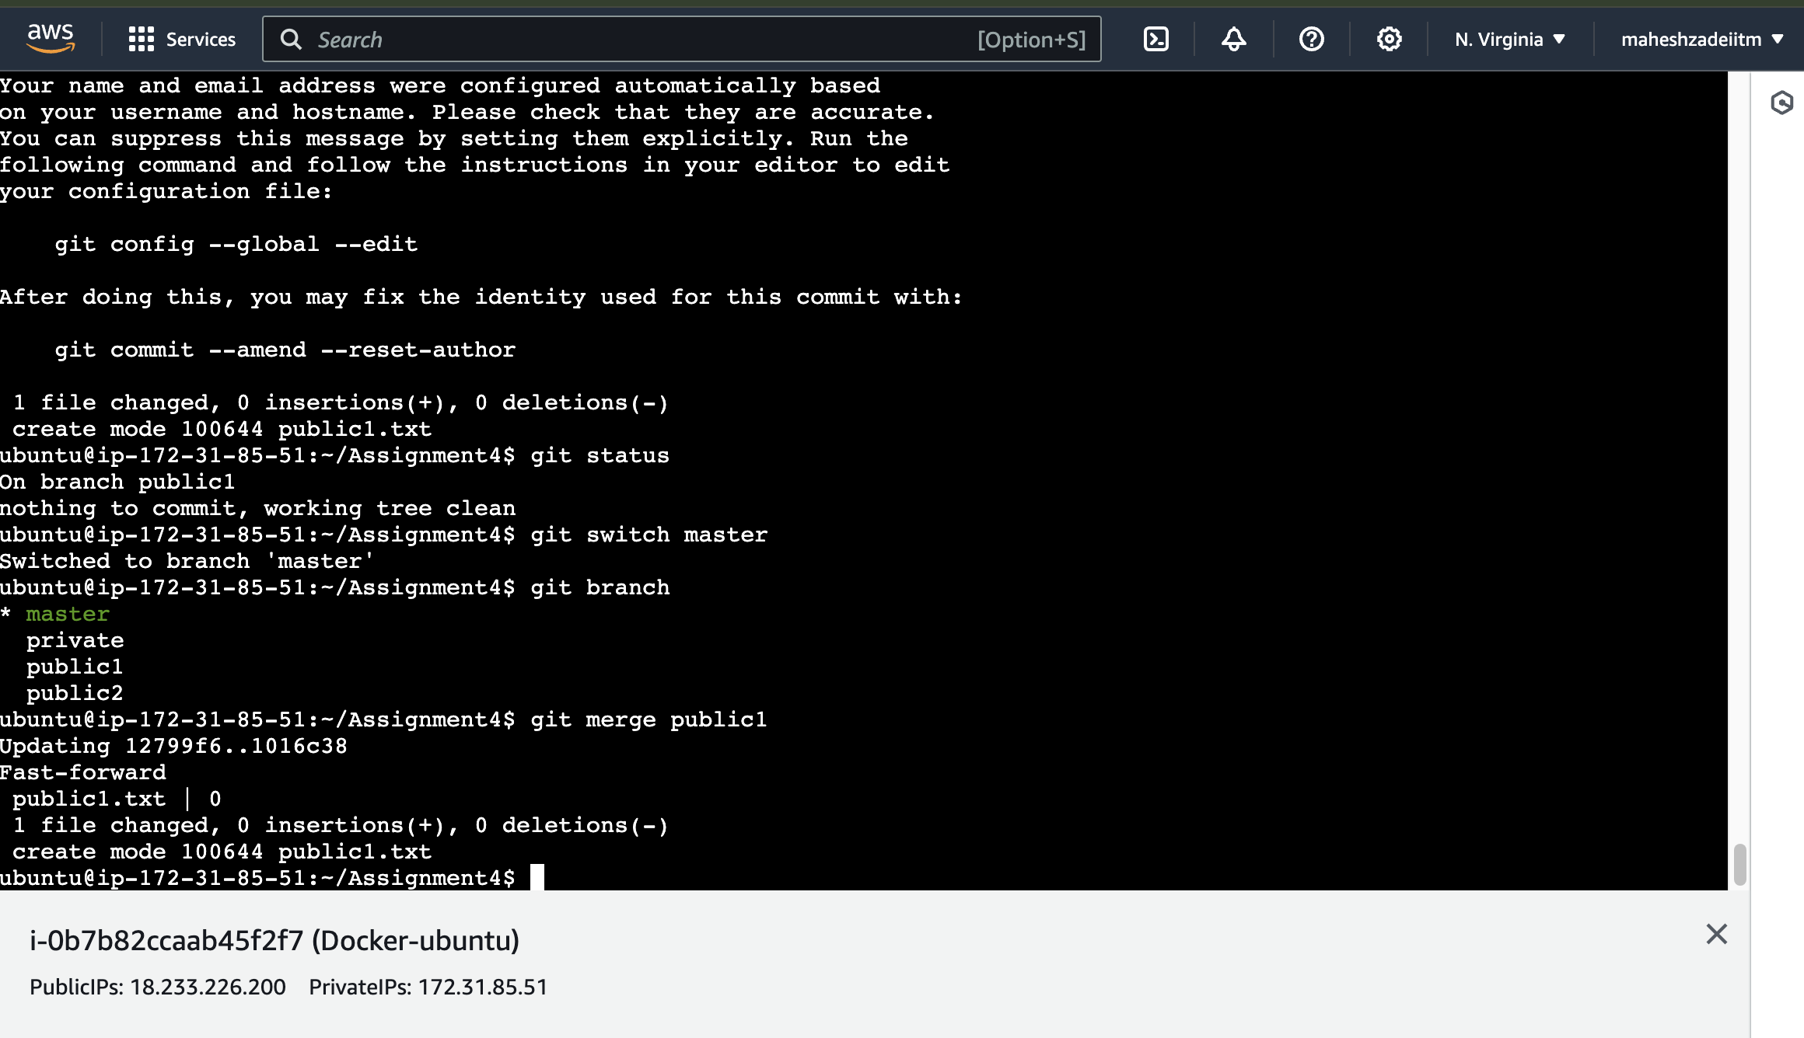

ubuntu@ip-172-31-85-51:~/Assignment4$ git merge public1

Updating 12799f6..1016c38

Check by ls in both the branch

ubuntu@ip-172-31-85-51:~/Assignment4$ git merge public1

Updating 12799f6..1016c38

Fast-forward

public1.txt | 0

1 file changed, 0 insertions(+), 0 deletions(-)

create mode 100644 public1.txt

ubuntu@ip-172-31-85-51:~/Assignment4$ ls

master.txt public1.txt

ubuntu@ip-172-31-85-51:~/Assignment4$ git switch public1

Switched to branch 'public1'

ubuntu@ip-172-31-85-51:~/Assignment4$ ls

master.txt public1.txt

ubuntu@ip-172-31-85-51:~/Assignment4$

now

Merge public 2 on master branch

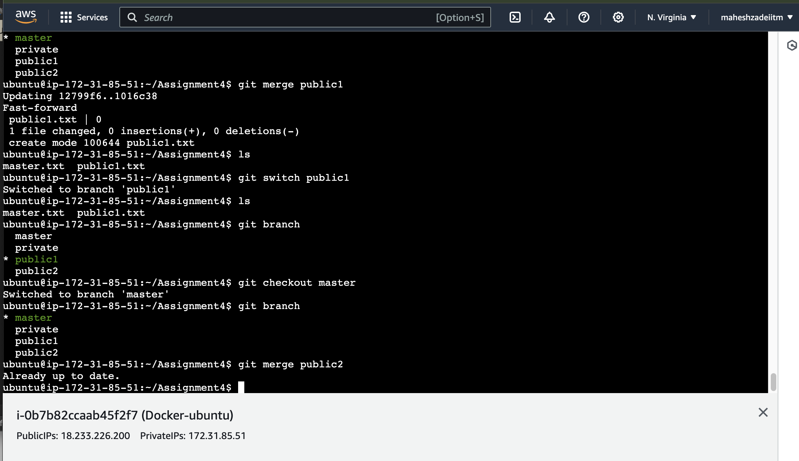

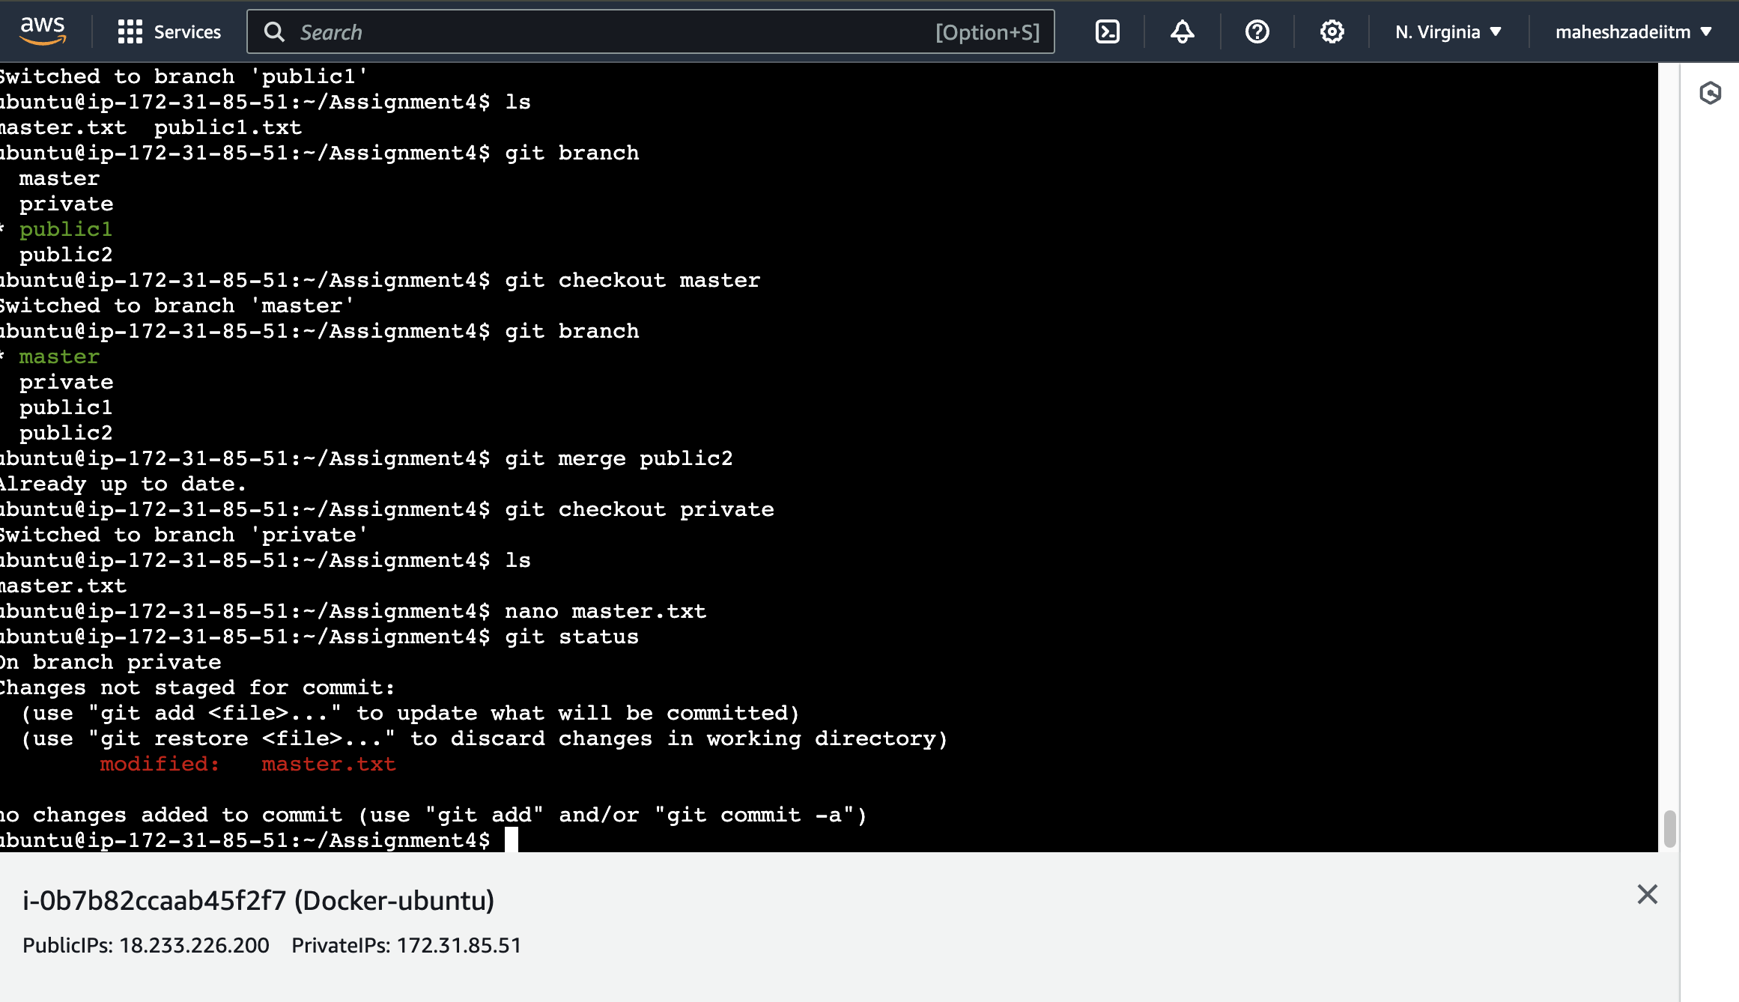

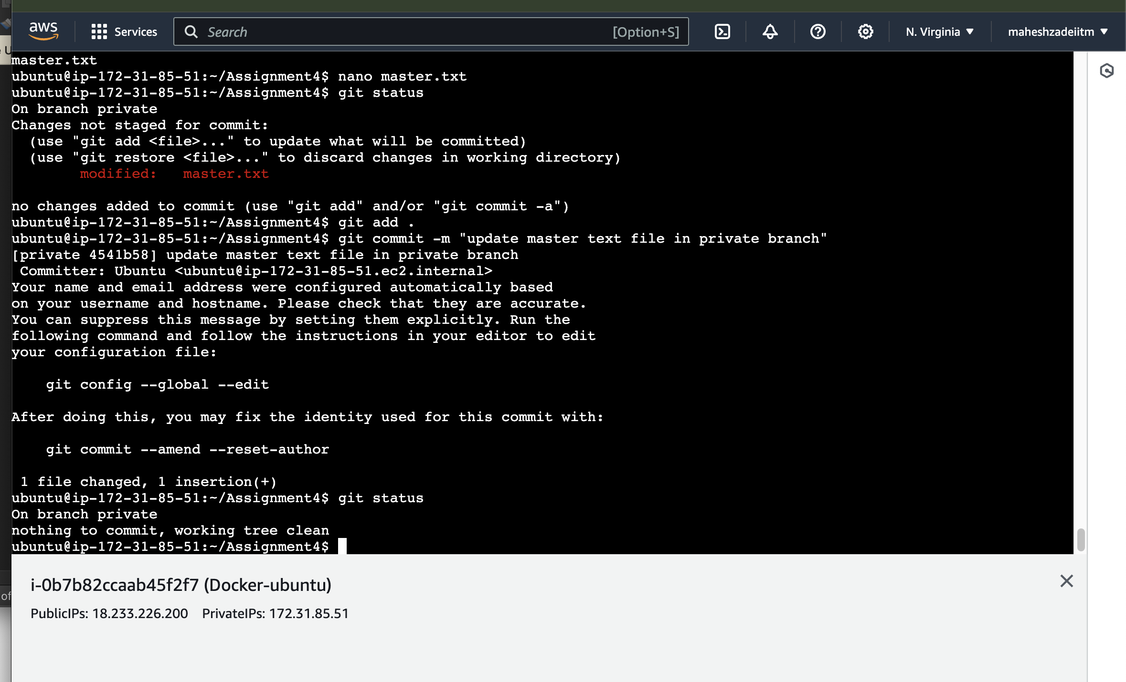

**ubuntu@ip-172-31-85-51:~/Assignment4$ cat master.txt**

**this file edite on private branch**

**ubuntu@ip-172-31-85-51:~/Assignment4$**

**File content is different in private branch**

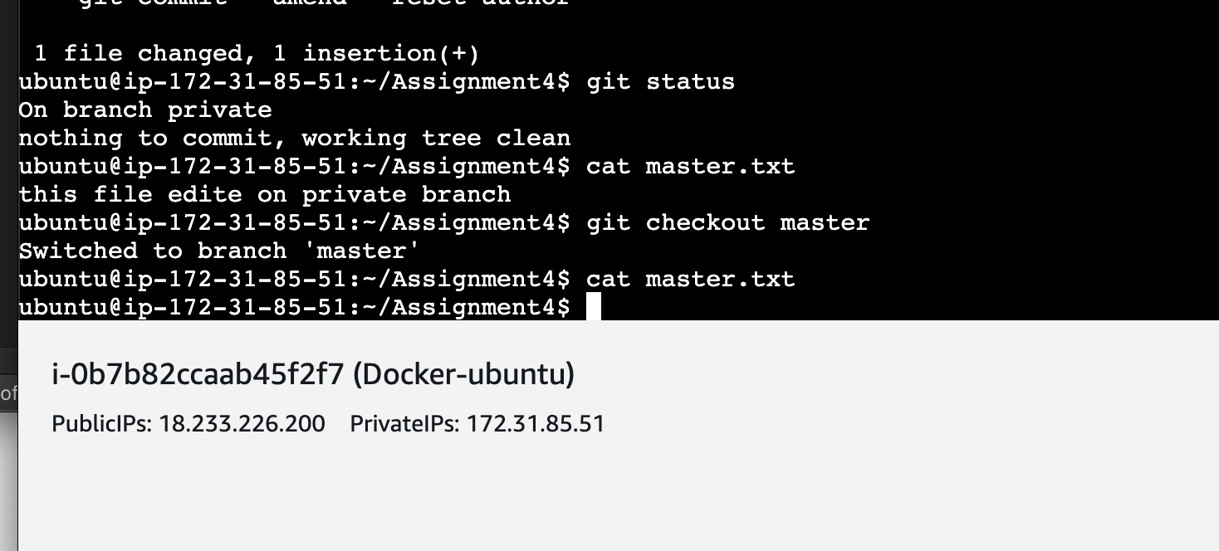

**ubuntu@ip-172-31-85-51:~/Assignment4$ cat master.txt**

**this file edite on private branch**

**ubuntu@ip-172-31-85-51:~/Assignment4$ git checkout master**

**Switched to branch 'master'**

**ubuntu@ip-172-31-85-51:~/Assignment4$ cat master.txt**

**ubuntu@ip-172-31-85-51:~/Assignment4$ git checkout public1**

**Switched to branch 'public1'**

**ubuntu@ip-172-31-85-51:~/Assignment4$ ls**

**master.txt public1.txt**

**ubuntu@ip-172-31-85-51:~/Assignment4$ cat master.txt**

**ubuntu@ip-172-31-85-51:~/Assignment4$**

**ubuntu@ip-172-31-85-51:~/Assignment4$**

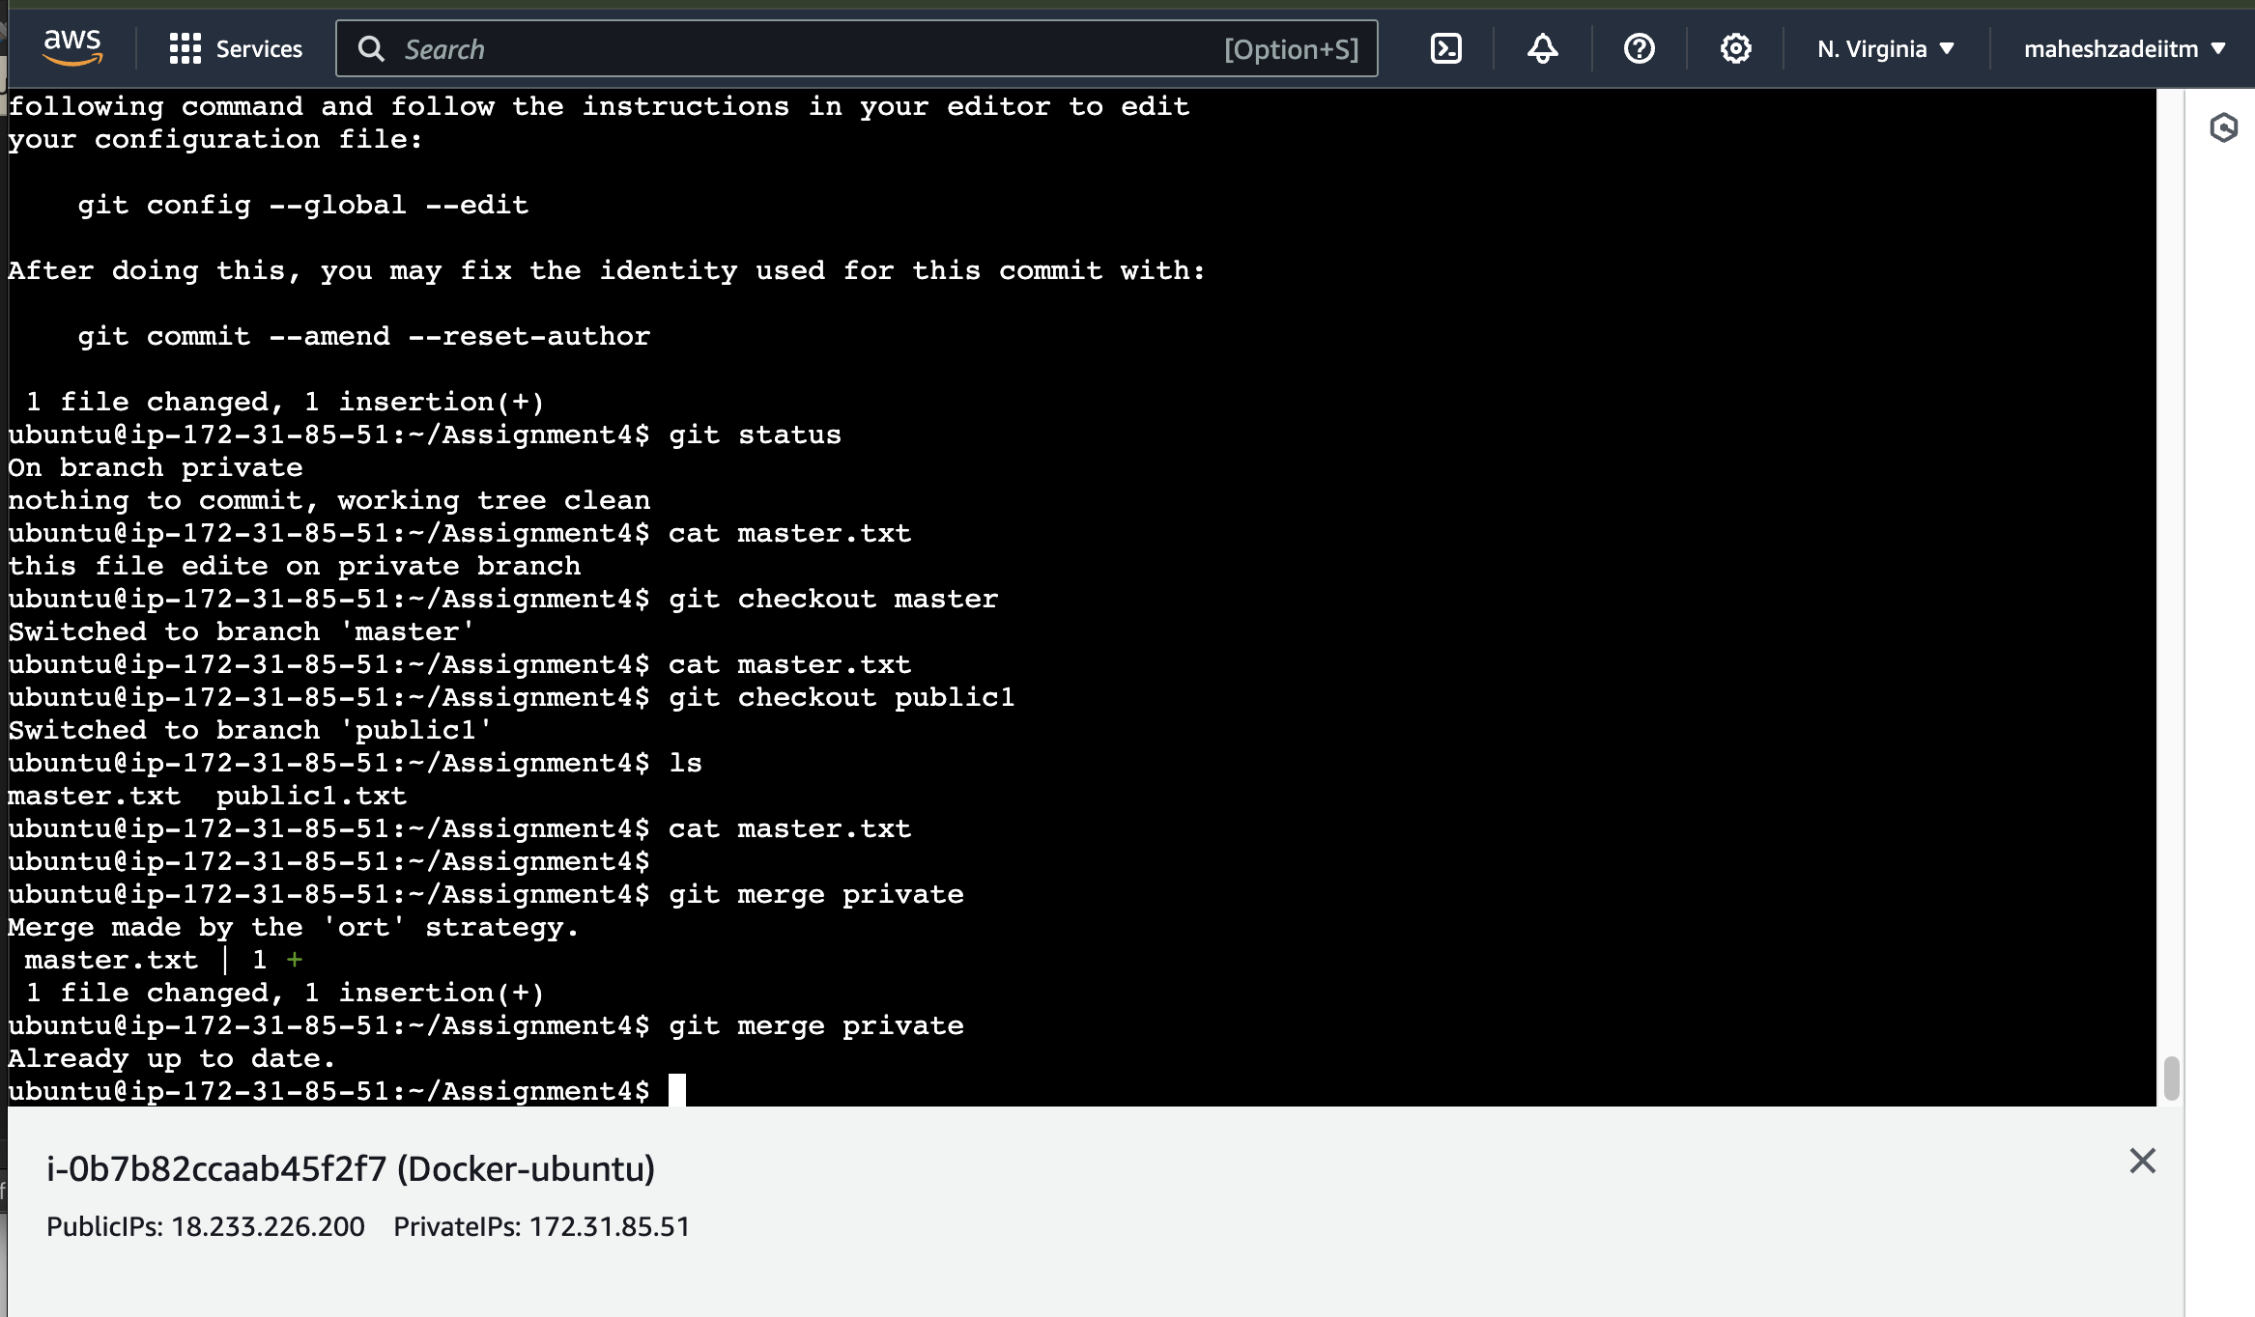

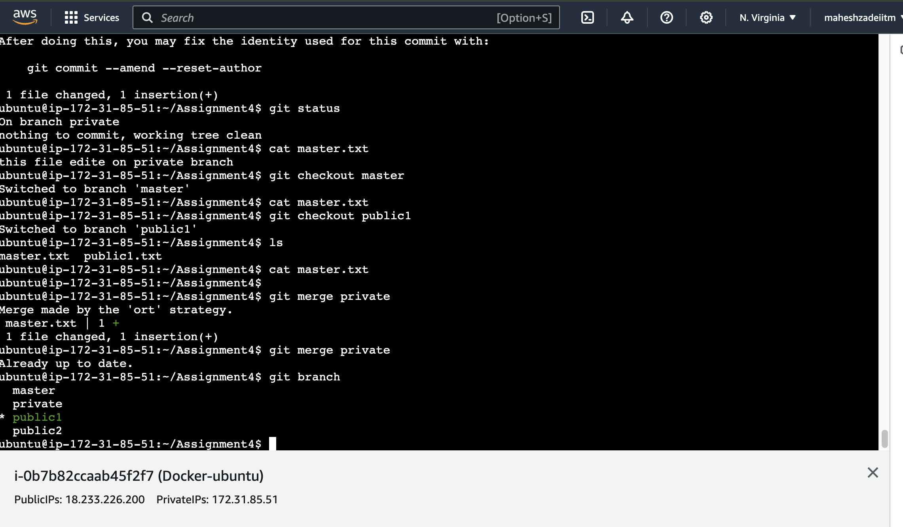

**ubuntu@ip-172-31-85-51:~/Assignment4$ git branch**

**master**

**private**

**\* public1**

**public2**

**ubuntu@ip-172-31-85-51:~/Assignment4$ ls**

**master.txt public1.txt**

**ubuntu@ip-172-31-85-51:~/Assignment4$**

**ubuntu@ip-172-31-85-51:~/Assignment4$ cat master.txt**

**this file edite on private branch**

**ubuntu@ip-172-31-85-51:~/Assignment4$**

**ubuntu@ip-172-31-85-51:~/Assignment4$ git checkout public2**

**Switched to branch 'public2'**

**ubuntu@ip-172-31-85-51:~/Assignment4$**

**ubuntu@ip-172-31-85-51:~/Assignment4$ cat master.txt**

**this file edite on private branch**

**ubuntu@ip-172-31-85-51:~/Assignment4$ git checkout public2**

**Switched to branch 'public2'**

**ubuntu@ip-172-31-85-51:~/Assignment4$ ls**

**master.txt**

**ubuntu@ip-172-31-85-51:~/Assignment4$ cat master.txt**

**ubuntu@ip-172-31-85-51:~/Assignment4$**

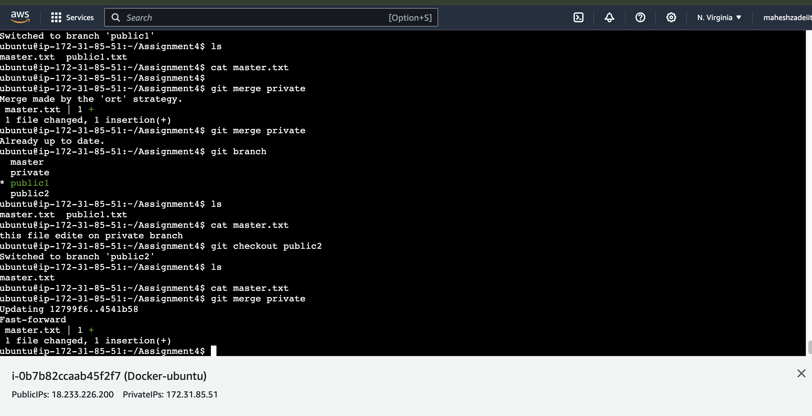

**u** **buntu@ip-172-31-85-51:~/Assignment4$ cat master.txt**

**this file edite on private branch**

**ubuntu@ip-172-31-85-51:~/Assignment4$**

**ubuntu@ip-172-31-85-51:~/Assignment4$ git checkout master**

**Switched to branch 'master'**

**ubuntu@ip-172-31-85-51:~/Assignment4$**

**ubuntu@ip-172-31-85-51:~/Assignment4$ ls**

**master.txt public1.txt**

**ubuntu@ip-172-31-85-51:~/Assignment4$**

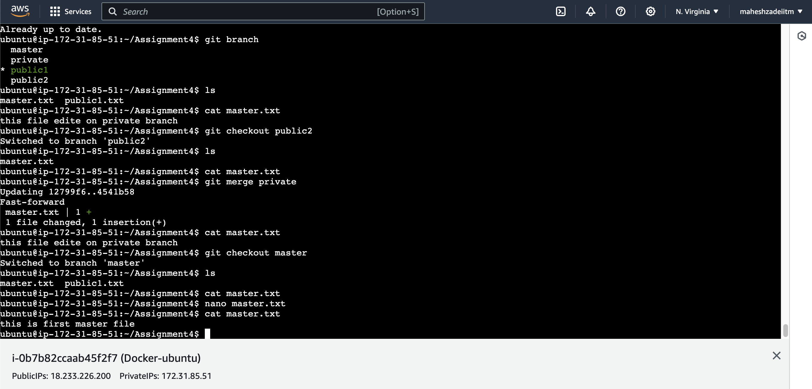

**ubuntu@ip-172-31-85-51:~/Assignment4$ git branch**

**\* master**

**private**

**public1**

**public2**

**ubuntu@ip-172-31-85-51:~/Assignment4$ git merge private**

**Already up to date.**

**ubuntu@ip-172-31-85-51:~/Assignment4$**

**ubuntu@ip-172-31-85-51:~/Assignment4$ cat master.txt**

**<<<<<<< HEAD**

**this is first master file**

**=======**

**this file edite on private branch**

**>>>>>>> private**

**ubuntu@ip-172-31-85-51:~/Assignment4$**

**buntu@ip-172-31-85-51:~/Assignment4$ git checkout private**

**Switched to branch 'private'**

**ubuntu@ip-172-31-85-51:~/Assignment4$ ls**

**master.txt**

**ubuntu@ip-172-31-85-51:~/Assignment4$**

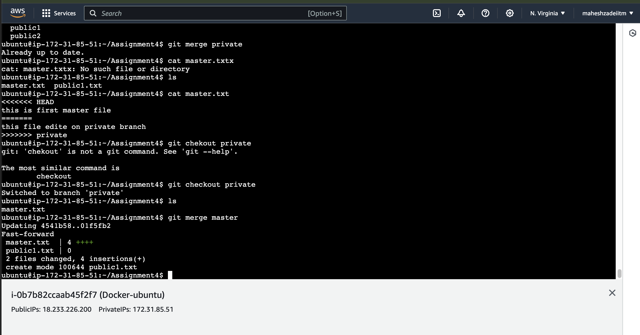

**ubuntu@ip-172-31-85-51:~/Assignment4$ ls**

**master.txt public1.txt**

**ubuntu@ip-172-31-85-51:~/Assignment4$**

**ubuntu@ip-172-31-85-51:~/Assignment4$ git merge public2**

**Already up to date.**

**ubuntu@ip-172-31-85-51:~/Assignment4$**